Detailed design
high-level architecture diagram
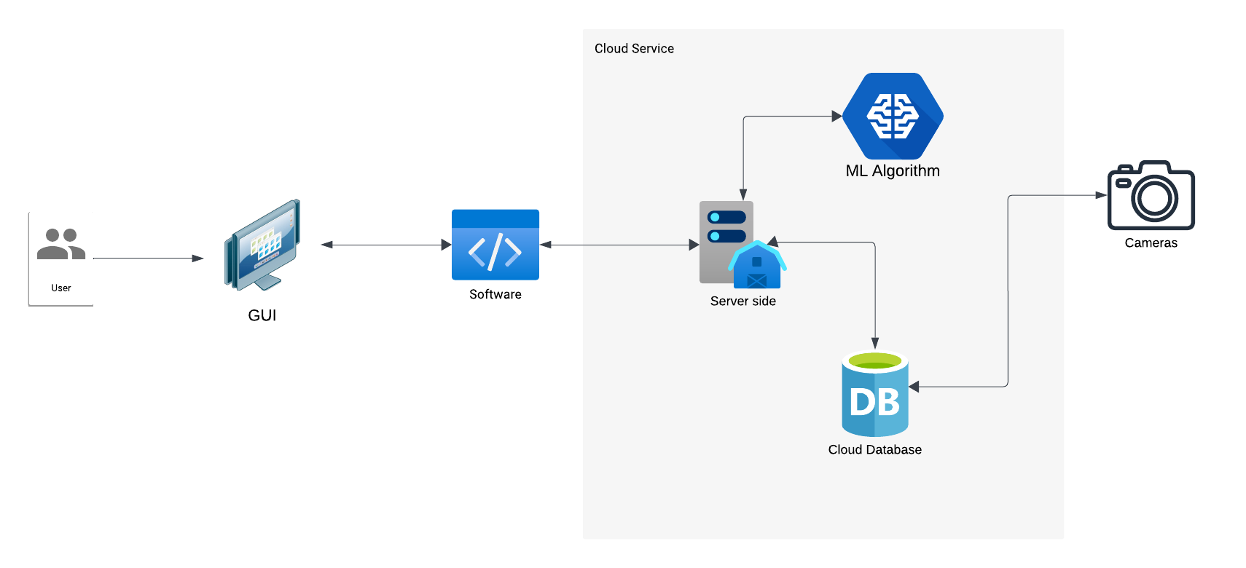

1.⁠ ⁠User:
- The user interacts with the system through a user interface (Dashboard) to view results, receive alerts, or configure the system.

2.⁠ ⁠Camera (Live Video Stream):
- Instead of a user uploading an image, a camera continuously streams live video to the server in real-time. This stream is the main input for the system.

3.⁠ ⁠Server Side (Cloud):
- The server acts as the processing hub in the cloud.
- It receives the live video stream from the camera and processes each frame of the video. Key steps include:
- Extracting individual frames from the live stream.
- Converting these frames into vectors (mathematical representations of visual features).
- Once the frames are converted into vectors, the server sends this data to the Machine Learning (ML) algorithm for analysis.

4.⁠ ⁠Machine Learning (ML) Algorithm:
- The ML algorithm operates in real-time to analyze the vectors from the video frames. It performs tasks such as:
- Detecting potential problems or anomalies.
- Performing requested operations, like object detection, behavior analysis, or issue identification.
- This ensures immediate processing of live data.

5.⁠ ⁠Cloud Database:
- The cloud database stores processed results, analysis outcomes, relevant metadata and recordings. It also store historical data for future reference or to improve the ML model over time.

6.⁠ ⁠Server-to-User Communication:
- Once the ML algorithm processes the video frames and determines results, the server sends the results back to the user interface in real-time.
- Users can view live updates or receive notifications, ensuring they remain informed about the system’s findings.

class diagram
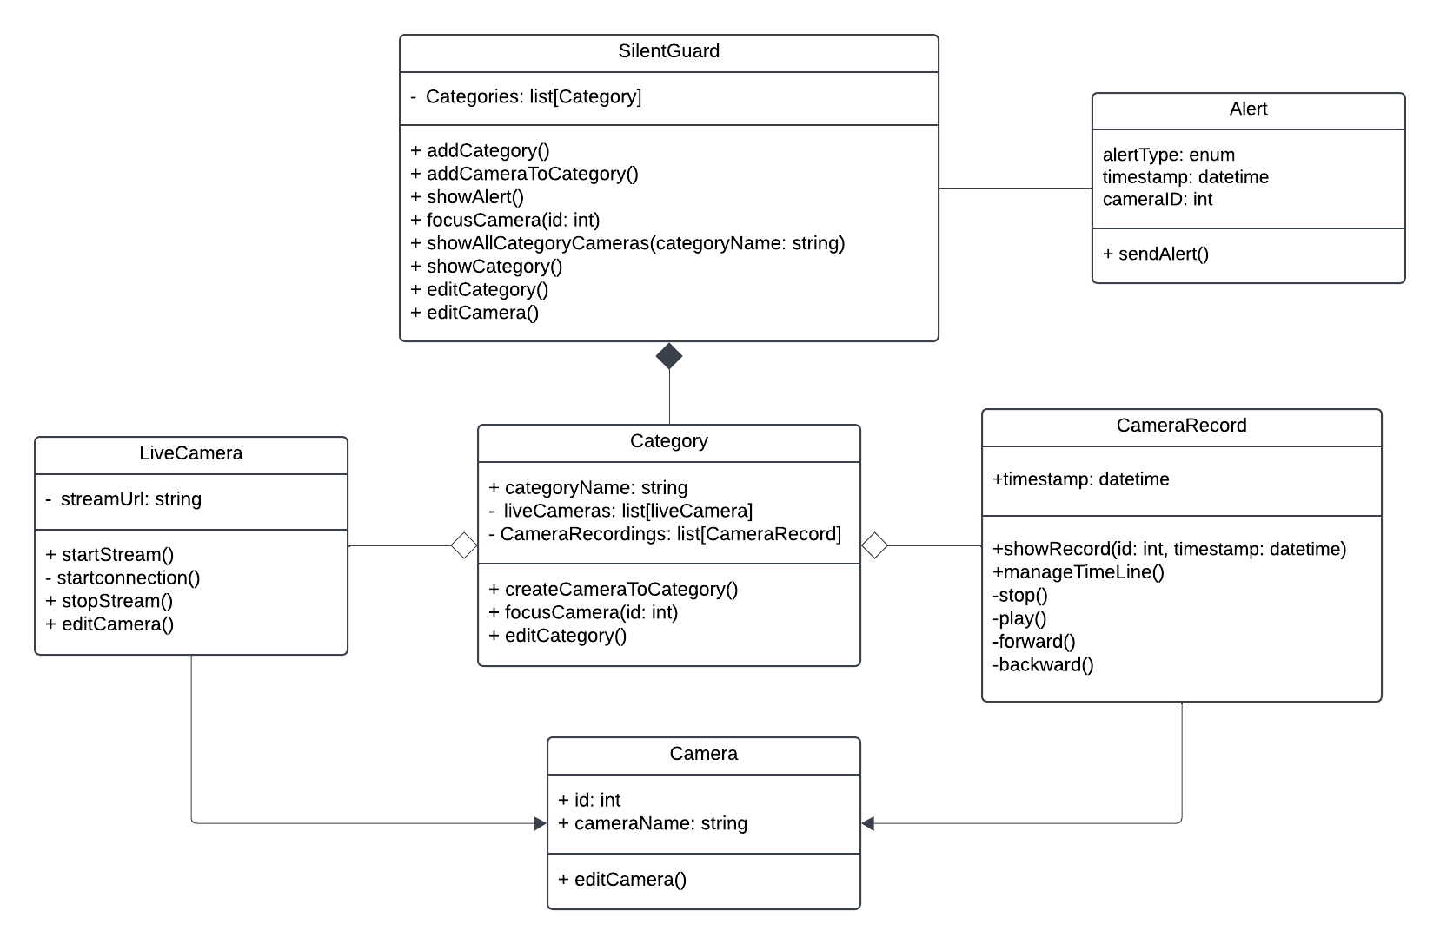
SilentGuard (Main Component)
- Attributes:
  - Categories: A list of Category objects representing different categories in the system.
- Methods:
  - addCategory(): Adds a new category to the system.
  - addCameraToCategory(): Adds a camera to a specific category.
  - showAlert(): Displays alerts related to cameras.
  - focusCamera(id: int): Focuses on a specific camera based on its ID.
  - showAllCategoryCameras(categoryName: string): Displays all cameras in a given category.
  - showCategory(): Displays information about a specific category.
  - editCategory(): Edits details of an existing category.
  - editCamera(): Edits details of a specific camera.

Category
- Attributes:
  - categoryName: The name of the category.
  - liveCameras: A list of LiveCamera objects within this category.
  - CameraRecordings: A list of CameraRecord objects associated with this category.
- Methods:
  - createCameraToCategory(): Creates a new camera within the category.
  - focusCamera(id: int): Focuses on a specific camera in this category based on its ID.
  - editCategory(): Edits details of the category.

LiveCamera
- Attributes:
  - streamUrl: The URL for the live camera stream.
- Methods:
  - startStream(): Starts the live camera stream.
  - startConnection(): Establishes a connection to the live camera.
  - stopStream(): Stops the live camera stream.
  - editCamera(): Edits details of the live camera.

Camera
- Attributes:
  - id: A unique identifier for the camera.
  - cameraName: The name of the camera.
- Methods:
  - editCamera(): Edits details of the camera.

CameraRecord
- Attributes:
  - timestamp: The date and time of the recording.
- Methods:
  - showRecord(id: int, timestamp: datetime): Displays a specific recording based on its ID and timestamp.
  - manageTimeLine(): Manages the timeline of recordings.
  - stop(): Stops the playback of a recording.
  - play(): Plays a recording.
  - forward(): Fast-forwards the playback.
  - backward(): Rewinds the playback.

Alert
- Attributes:
  - alertType: An enum indicating the type of alert.
  - timestamp: The date and time when the alert occurred.
  - cameraID: The ID of the camera that triggered the alert.
- Methods:
  - sendAlert(): Sends an alert notification.

Relationships
- SilentGuard - Category: The SilentGuard class manages multiple Category objects.
- Category - LiveCamera: Each Category contains multiple LiveCamera objects.
- Category - CameraRecord: Each Category is associated with multiple CameraRecord objects.
- LiveCamera - Camera: The LiveCamera class extends or relates to the Camera class, sharing its core attributes and methods.
- Alert - Camera: Alerts are associated with specific cameras, as indicated by the cameraID attribute.

